Joseph Godinez

Professor Oscar Ho

Computer Science 240-20

October 28, 2021

1. The program is storing positive values into Register 0 and adding them in R0

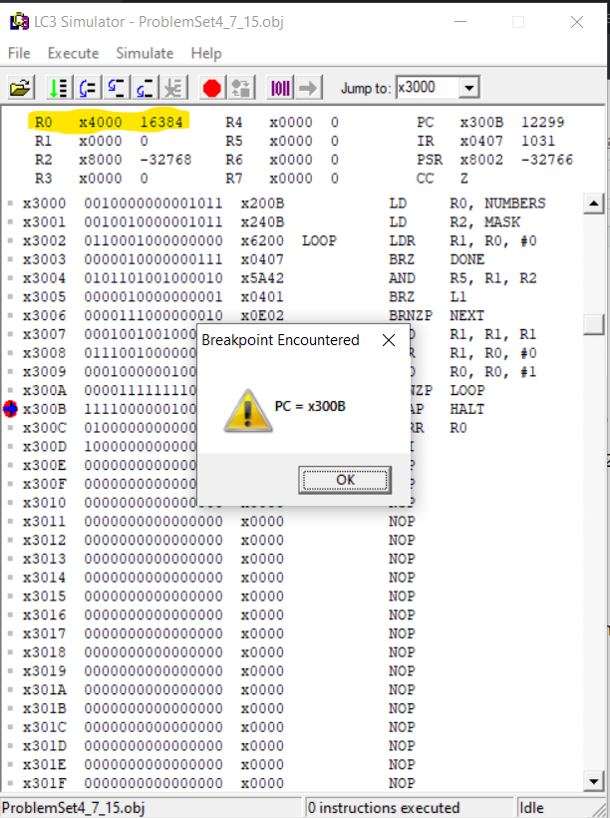

1. The program in 7.16 clears Register 3 and 4 then the loop starts. Basically the programs count all the even and odd integers. Which are then stored in R3 and R4 the value of how many even and odd numbers.

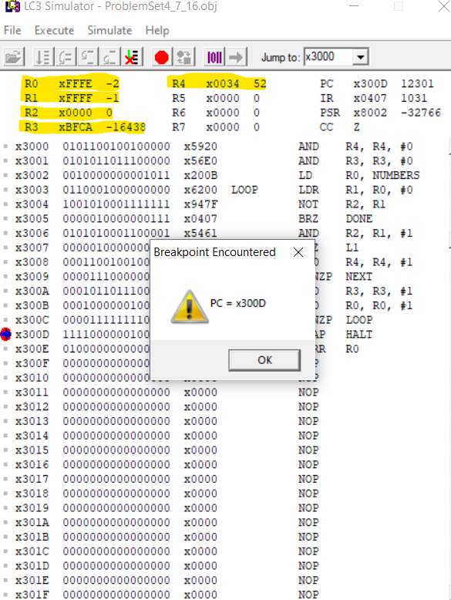

1. The missing lines are {LDR R3, R4, #0| NOT R3, R3| ADD R3, R3, #1} LDR is loading the address first. Then compare the characters and last is to add the characters in R3.

